Week 10 - S10 - Advanced OOP - UML Diagram - Lab Problem

**Name:** Ramesh Harisabapathi Chettiar

**Date of Submission:** 22/10/25

**QNO1🡪**

**Problem Statement:**

Draw a UML Class Diagram for a simple Library Management System with classes like Book,

Member, and Librarian. Show relationships such as association and aggregation.

**Hints:**

● Use attributes and methods inside each class.

● Show 1-to-many association between Member and Book.

● Mark the relationship direction using arrows.

LibraryManagementSystem.java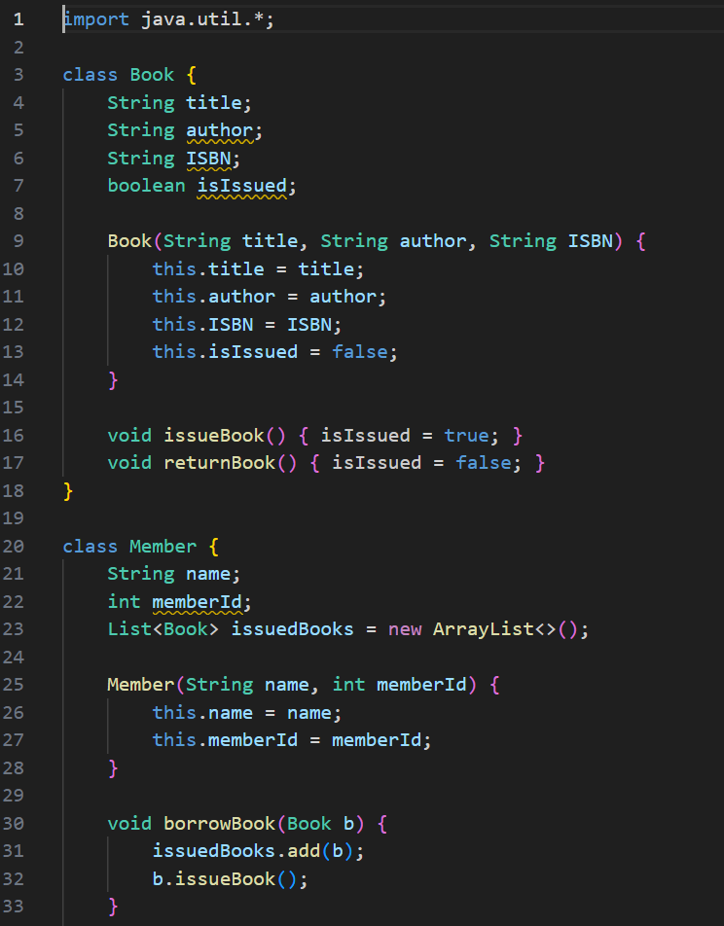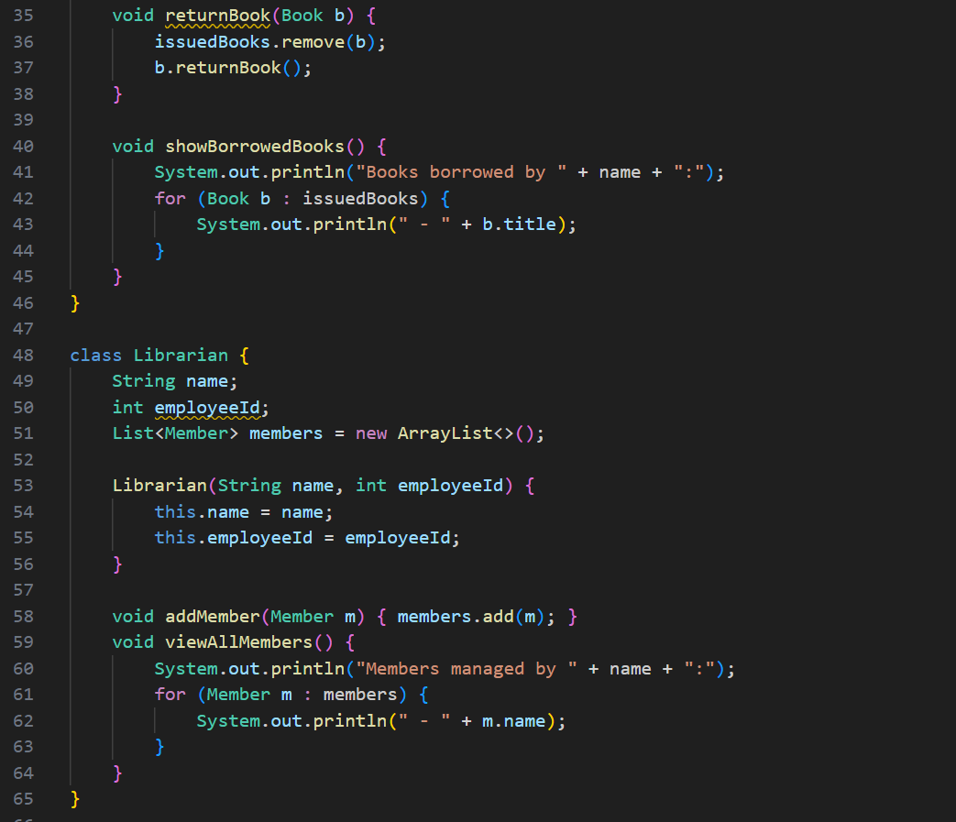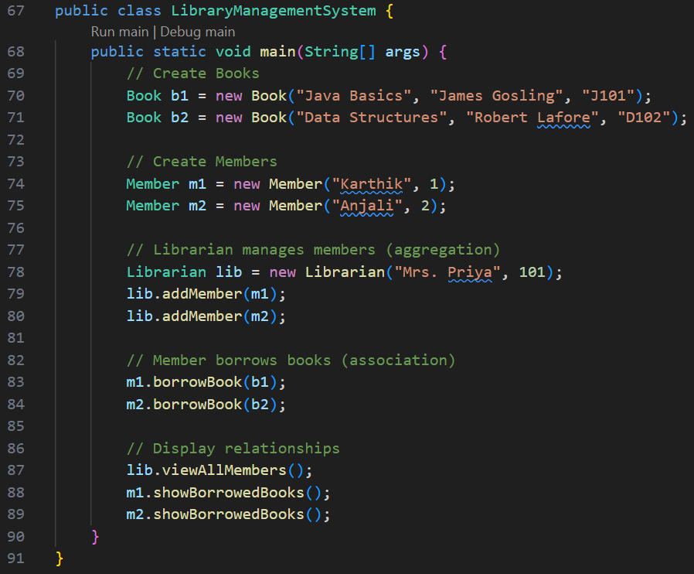

**OUTPUT🡪**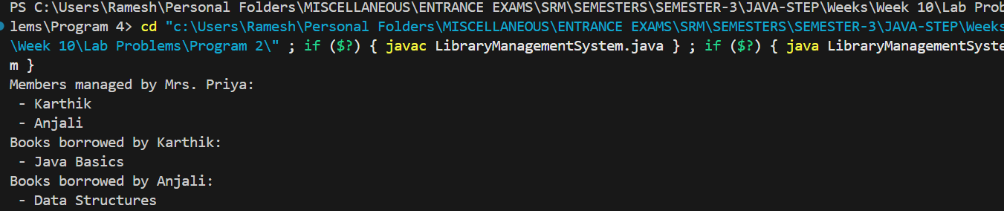

**QNO2🡪**

**Problem Statement:**

Draw an Object Diagram representing real instances of classes Student and Teacher where

each teacher guides two students.

**Hints:**

● Show object names (e.g., teacher1:Teacher, student1:Student).

● Indicate object links (runtime relationships).

● Keep attribute values simple (e.g., name = "Karthik").

**ObjectDiagramDemo.java**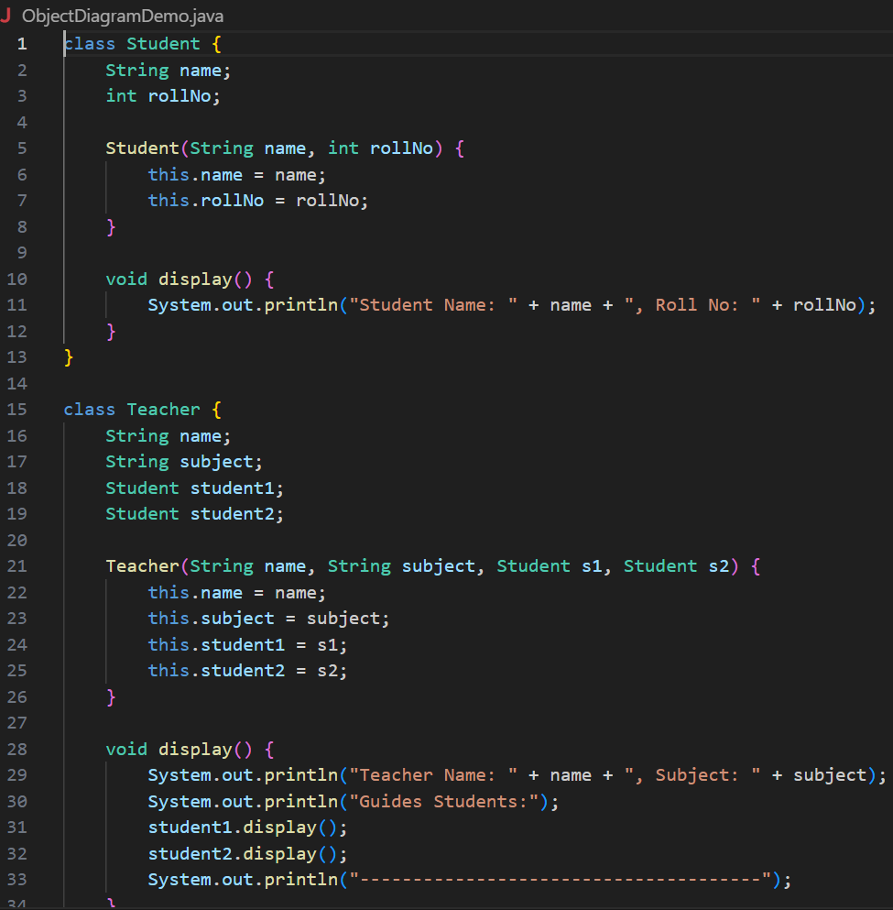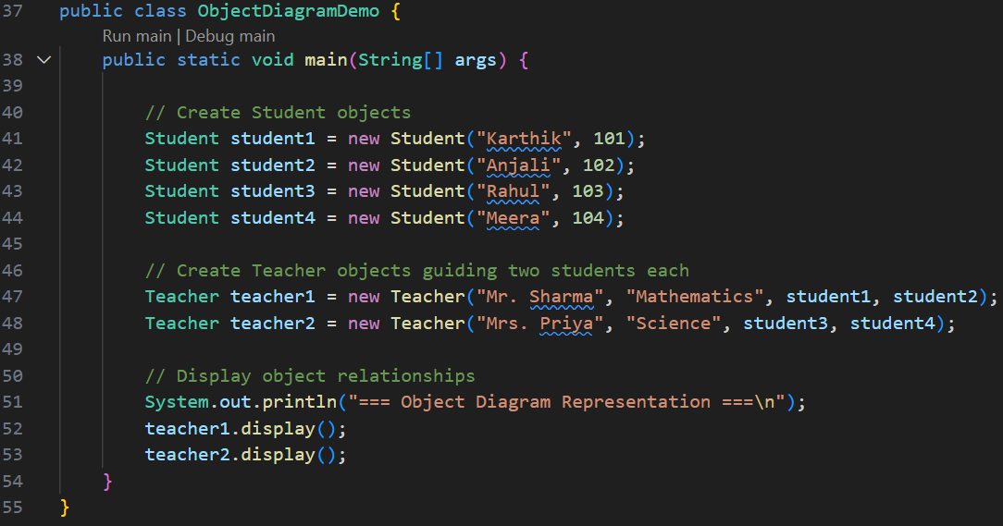

**OUTPUT🡪**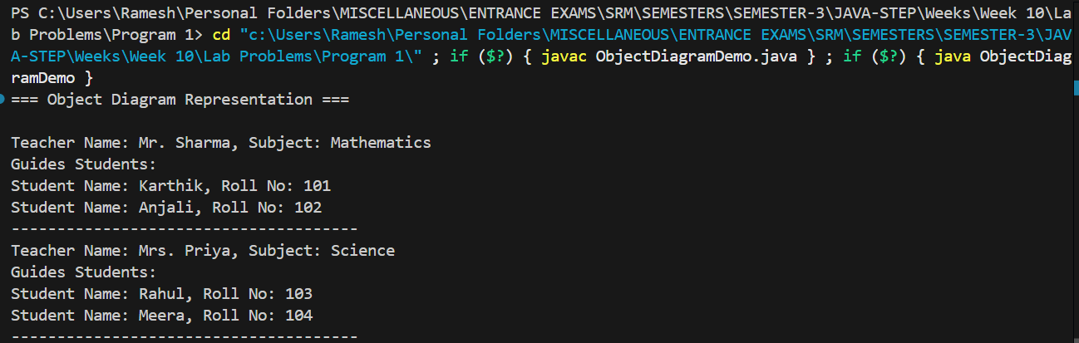

**QNO3🡪**

**Problem Statement:**

Draw a Sequence Diagram showing the process of placing an order on an e-commerce

website. Include Customer, OrderService, PaymentGateway, and InventoryService.

**Hints:**

● Show the flow of method calls from customer to services.

● Include return arrows to indicate responses.

● Use activation boxes for ongoing operations.

ECommerceSequence.java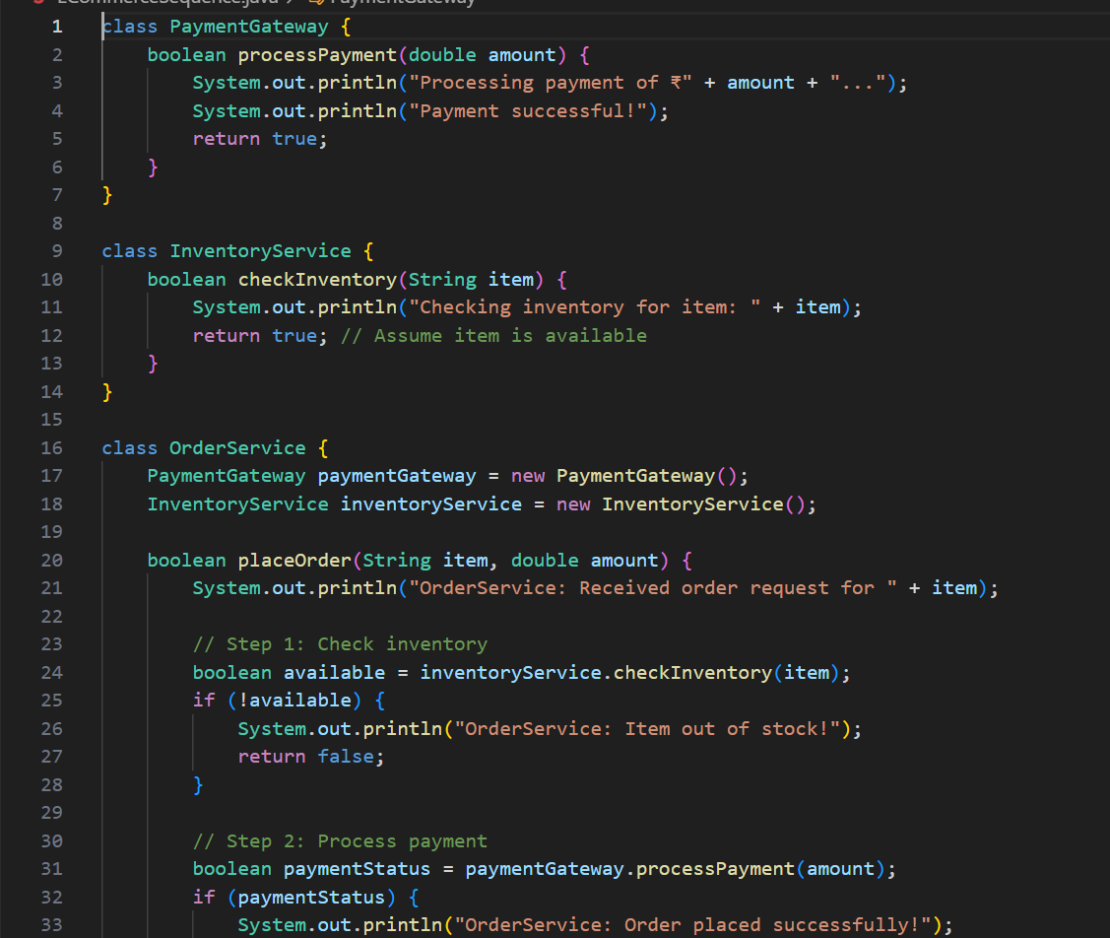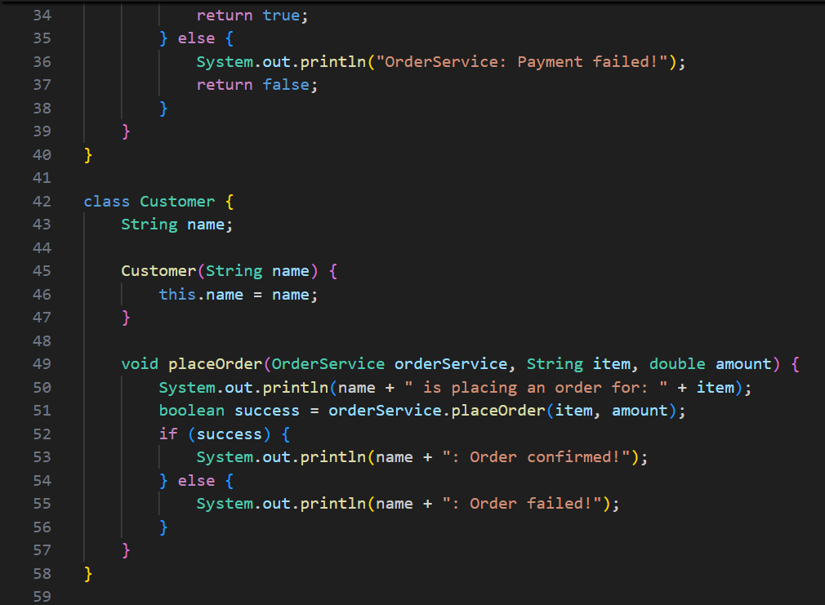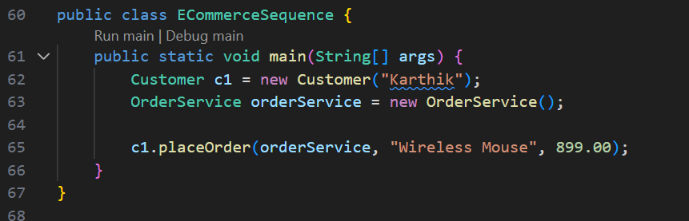

**OUTPUT🡪**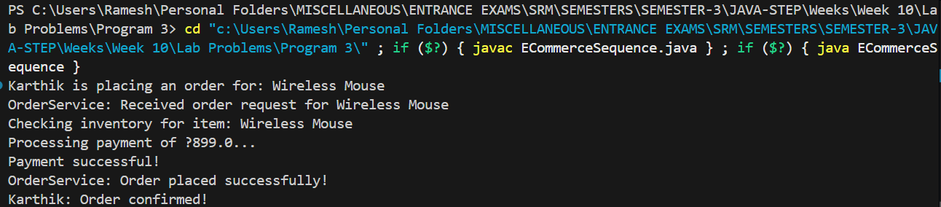

**QNO4🡪**

**Problem Statement:**

Draw a Use Case Diagram showing the main user actions in an ATM system such as

Withdraw Money, Check Balance, and Deposit Money.

**Hints:**

● Use actor symbols for users.

● Connect actors to use cases with lines.

● Optionally use include or extend relationships.

**ATMUseCaseDemo.java**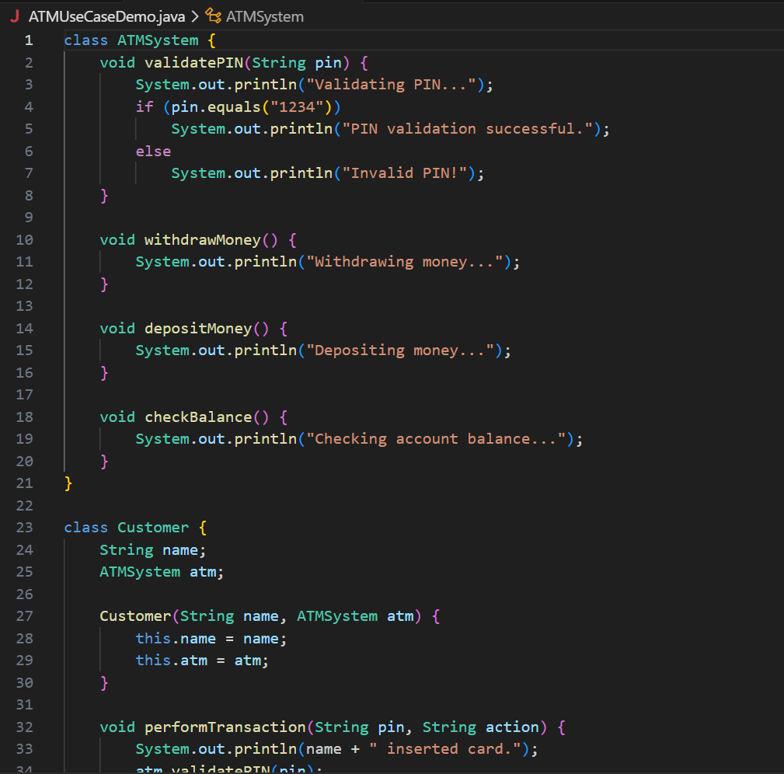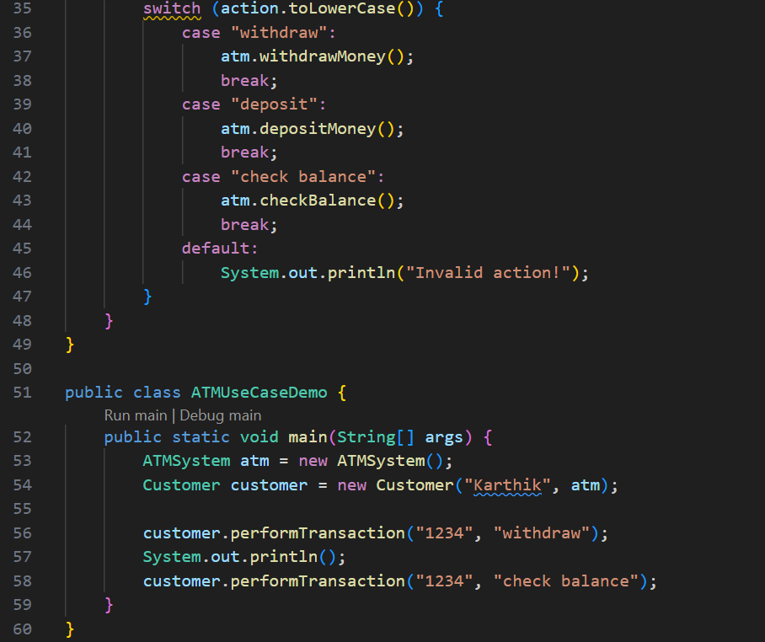

**OUTPUT🡪**

